Learning Disabilities Innovation Fund
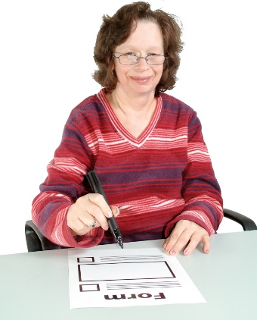 | Guide to applying.
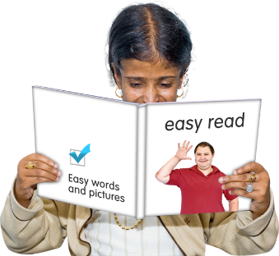 | Easy Read

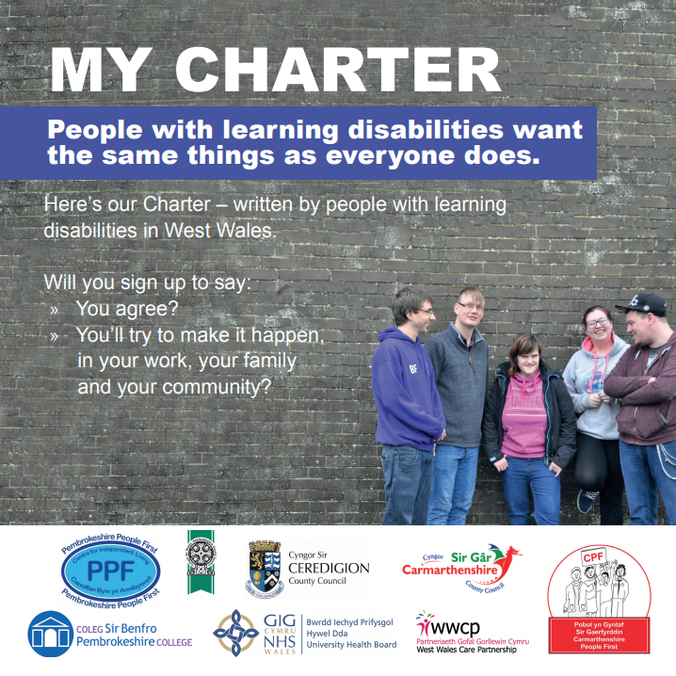 | The Charter  Your project must meet 1 or more parts of the Learning disability charter.
The charter was written by people with a learning disability from Carmarthenshire, Pembrokeshire and Ceredigion.
You can find out more here:
www.pembrokeshirepeople1st.org.uk

West Wales Learning
Disabilities Charter
People with learning disabilities want the same things as everyone else does.
- My Life, My Rights
More chances in life; more choice; to be listened to; to be treated as adults; to be given dignity and respect & for you to keep our information private.
- My Community. My Relationships
To be able to travel independently; help to understand money so we have more control; to train other people in what our lives are like – we’re the experts; to get involved with our community; to have paid jobs; the right to enjoy friendships and sex, just like everyone else and the right to have a family.
- My social life
To go places everyone else goes and be welcome; to do stuff in the evenings and at weekends; to enjoy friendships, relationships and sex as we choose; for people to welcome us and understand what we need when we are out and to have more info about what’s going on.
- My Support
Help to follow our dreams; to train staff who work with us; to get to know people who support us; to trust people to do what they say and to have access to advocacy.
- My Health
To have the healthcare we need from GPs and hospitals; have a health check every year; staff to have training by us; to have appointments that are easy to get , and on time and control over our health – they are our bodies !
- My Independence
To give us space – not too much at once; to feel safe – to help us find out about bullying and hate crime, and what to do about it; time to think for ourselves; support to live on our own if we want; support when we are parents and to stand up for our rights !
- My Communication
To make things easy to read; letters & leaflets we can understand – keep it simple! to find out what works for us – we are all different; to speak for ourselves and have time to think and answer – don’t rush!

 | About the fund
The fund is for new ideas from people with a learning disability.
It is for ideas for new activities and services and to test if they work.
The fund is for third sector and statutory bodies who want to
co-produce projects with people with a learning disability.
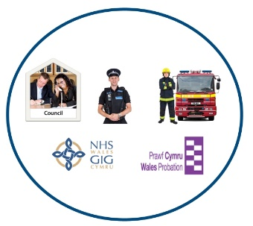 | Statutory bodies are organisations like Councils, Health Boards or National Parks.

 | The funding
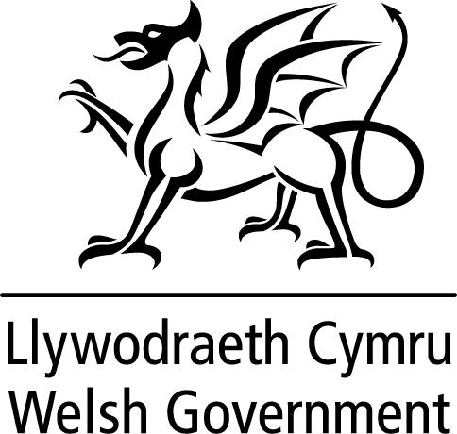 | This is a new grant.  The money comes from the Integrated Care Fund (ICF).
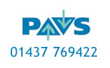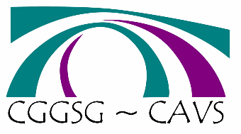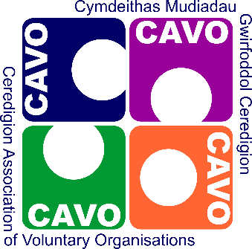 | Pembrokeshire Association of Voluntary Services (PAVS) are in charge of the fund. They are working with:  - Carmarthenshire Association of Voluntary services (CAVS)  - Ceredigion Association of Voluntary Organsiations (CAVO)
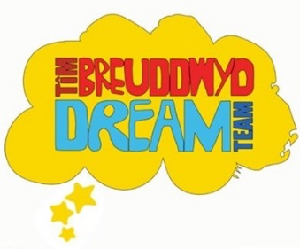 | The Regional Improving Lives Partnership (RILP) will run the fund. They are chaired by the Dream Team and supported by Pembrokeshire People First.
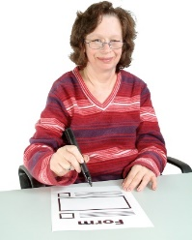 | Who can apply?
To apply you must be:
- Voluntary or community group
- Social enterprise
You must be properly set up with rules and a strong structure.
You must have a bank account that needs 2 or more signatures.
You must support people with a
learning disability.
If you are a statutory body, you can apply if:
- your project is co-produced by people with a learning disability
- you show strong links to the charter.
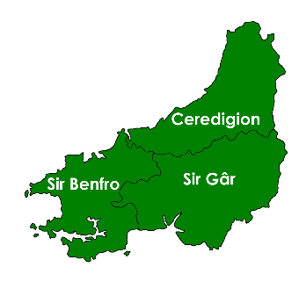 | The fund is for projects in West Wales:  - Pembrokeshire  - Carmarthenshire  - Ceredigion
 | Your project idea must be:
 | - A new idea that will change the way people with learning disabilities are supported
 | - Co- produced and co- delivered by people with a learning disability
 | - Clearly benefit people with a learning disability
 | - Be able to share what you learn
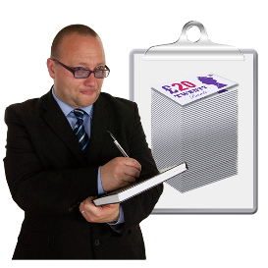 | - Be good value for money
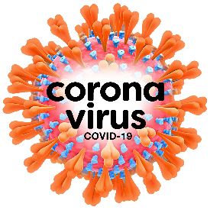 | You will need to explain how you project will follow Covid guidelines  and rules.

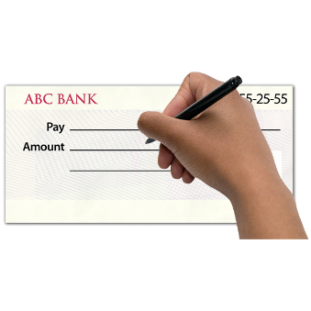 | What can the grant be spent on?
£10,000 | The fund will pay for £10,000 for each project. This can be the full cost of the project. You won’t need to add any money of your own.
 | The grant is for ongoing costs
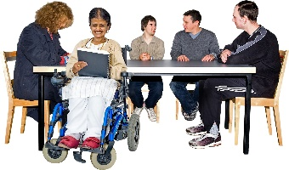 | Ongoing costs are things like wages and room hire.
 | You can ask for 20% of your grant for capital costs.
 | Capital costs are things you buy once. This could be things like laptops or cameras.

 | What you cannot spend the grant on
- Activities or services that already exist.
- Costs for your project that happened before you applied for the grant
- A small part of a big project, unless it is for a part that can stand on its own.
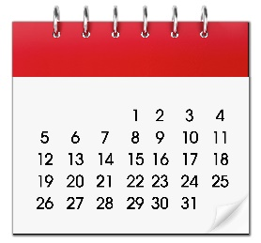 | How long is the grant for?
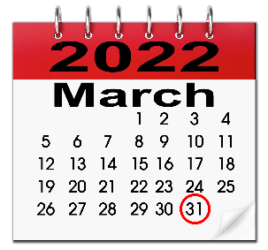 | You must finish the project and spend the money by 31 march 2022.
 | Monitoring your project.
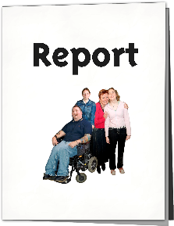 | You will need to write a short report at the end of your project.  You will need to do this no more than 2 weeks after you finish.
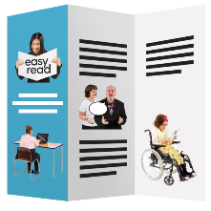 | Publicity  You need to tell people about the grant and the funders when you talk about your project. This means on:  - Posters  - Leaflets  - Website  - Social media
More information and support
You can ask your local volunteer council for support and more information.
- Pembrokeshire Association of Voluntary Services (PAVS)
E-mail: development@pavs.org.uk
- Carmarthenshire Association of Voluntary Services (CAVS)
E-mail: Jackie.Dorrian@cavs.org.uk
- Ceredigion Association of Voluntary Organisations (CAVO)
E-mail: gen@cavo.org.uk
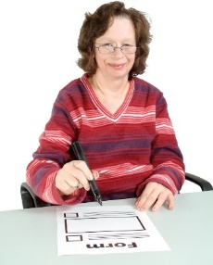 | Applying for the grant  You will need to complete a form
 | You will need to make a short film telling us about your project.
 | When you write your form you must:
- Show how your project is
co- produced by people with a learning disability
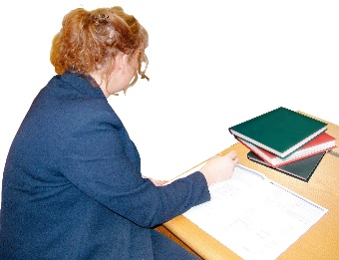 | - Make sure your costs are as accurate as possible.
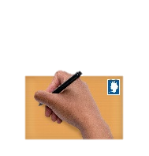 | - Include 2 quotes for anything that costs more than £500
 | - Show it is good value for money
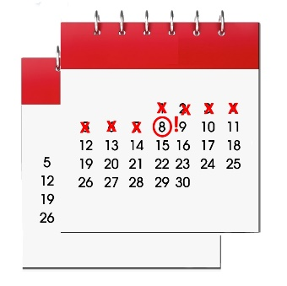 | Grant deadline  You must send your grant application by 10 September 2021.
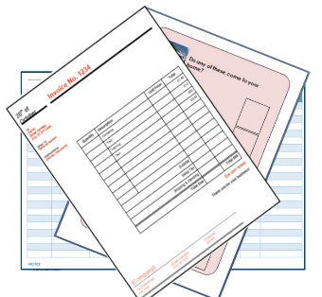 | You must send:  - your form  - a link to your film  - your governing documents.
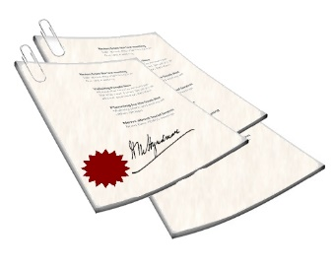 | Governing documents can be called:  - Constitution  - Memorandum & Articles of Association  - Trust Deed  They are the legal papers that form your organisation.

 | There will be 2 stages to decide who gets the grant.
Stage 1 Shortlisting
The Dream Team will look at the film and the form.
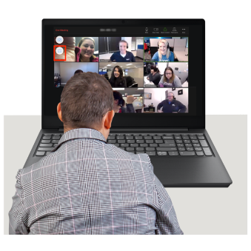 | Stage 2 presentation  If you are shortlisted, you will need to present to the panel and answer questions. This will be by Zoom.  The presentations will be on  29 September 2021.
 | ** You should complete the form in easy read. The next page gives some ideas about making the form easy to read for everyone.
 | You will be told by phone or email no more than 3 weeks after the deadline.
 | Things to think about when you write the form:
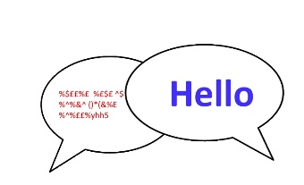 | - Use easy words
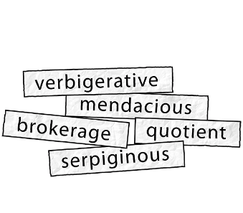 | - Try to avoid jargon or initials for things. If you have to use them explain what they mean.
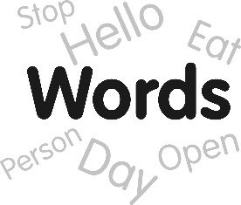 | - Use short sentences and short paragraphs.
Hello | - Use a simple font like arial
hello | - Use 16 point font sizes
 | - Ask your co- production team members to check the form is easy read.

