Learning Disabilities Innovation Fund
Application form
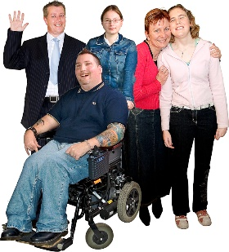 | Section A  About your organisation.
1.Contact details
Organisation name
Main contact persons name
Their role in the organisation
Address we should write to
Phone number
Email address

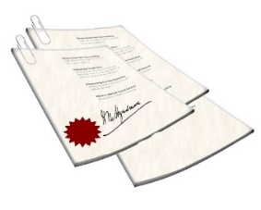 | 2.Your governing documents You need to send these with the application form.
Constitution |  |  | Articles of association
Trust deed |  |  | Rules

3.Tell us about your organisations aims and the main things you do

4. How many people are part of your group?
Committee Members |  | Volunteers
Paid staff |  | Members

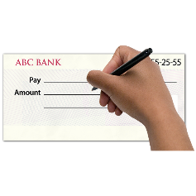 | 5. Your bank account
Bank or building society name:
Name of your account
We will pay the grant directly to your account. We will ask for your bank details if you are offered a grant.

Section B
Your project
6.Your project
Name of our project
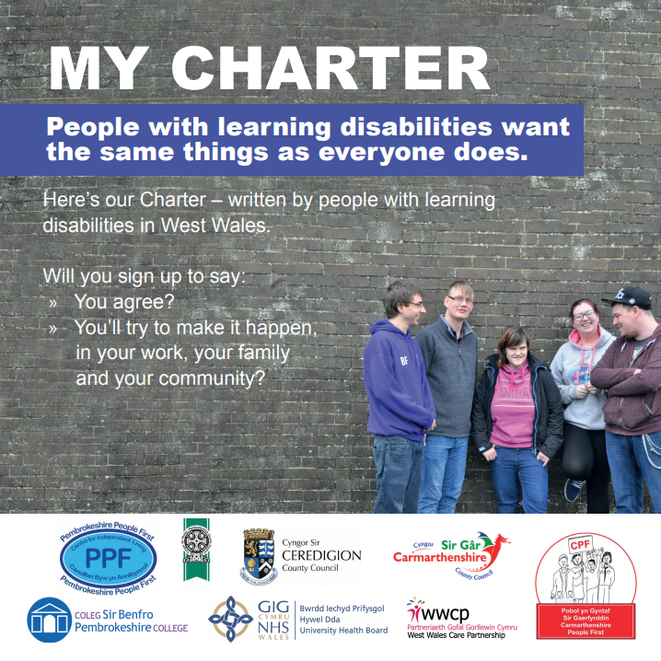 |  |  | Which themes of the charter will your project support?  You can tick more than one.
My Life, My Rights |  |  |  |  | My community. My Relationships
My social life |  |  |  |  | My Support
My Health |  |  |  |  | My Independence
My Communication
 | How much money are you asking for |  |  |  |  |  | £
When will your project start?
When will your project finish?
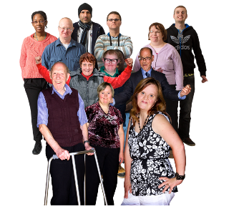 |  | 7.Tell us about the people with learning disabilities you want to support.
Tell us:
- where they live
- How many people will you support?
- How will you let them know about the project?
8. Tell us how you are
co-producing your project with people with learning disabilities.
Tell us:
- Who has been involved developing the project?
- How did you work with them?
- How will they help run the project?

9. Tell us about your project.
Tell us how it will help the charter.
Tell us:
- How you will use the money for each part of
the charter?
- Why is the money needed?
You can tell us more in your film
 | 10. Tell us how your project is new and different.
Tell us how your project will find new ways to support and work with people with a learning disability.
 | 11. Tell us how your project will keep people safe from COVID 19
 | 12. Tell us about the good your project will do
Tell us how you will make things better for:
- Your organisation
- Volunteers
- Communities
- People
 | 13. How will you show your project has worked?
Section C
Money
 | You need to tell us what you will do with the money.
 | Tell us about any match funding you have. You do not need match funding to get this grant.
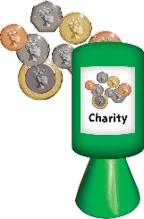 | Match funding is extra money for the project from other funds or grants.

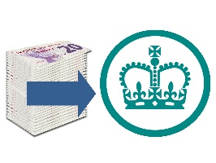 | Tick if you are VAT registered
 | You cannot claim VAT with this grant.
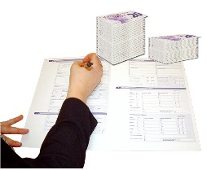 | If you are not VAT registered you must give the costs including VAT.
 | If anything costs more than £500 you need to have 2 quotes.

What you are paying for: | How much (WITH VAT) | How much you are asking for
Match funding
Total | £ | £

Declaration
We are signing to say all the information in this form is correct.
If we are given a grant we will only use the money for the project we have told you about.
Your organisation name
Signed by
Your role in the organisation
Date

 | What next?
 | checklist
 | I have read all the notes and guidelines
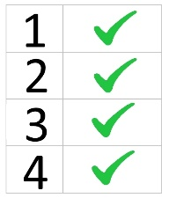 | I have answered all the questions
 | I have filled in the declaration.
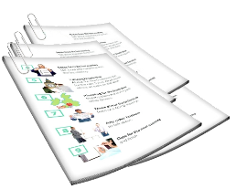 | I have kept a copy for me
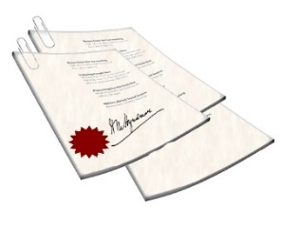 | I am sending my governing documents
 | I have sent my film

Send your finished form to:

PAVS
36/38 High Street
Haverfordwest
SA61 2DA

Or email to:
development@pavs.org.uk

Data protection
We keep your application in our records. We keep it safe and only share it with the decision panel and the funders.
We may tell other people about successful projects, but we will not share personal information.

