Agenda
Rhwydwaith Network
Dyddiad/ Date | Amser / Time | Lleoliad / Venue | #
25/08/2021 | 10:30 | Zoom | 002

Bydd cyfarfodydd drwy Zoom yn cael eu recordio i gefnogi gydag adroddion a chofnodion ac er mwyn rhannu cyflwyniadau y cytunwyd arnynt YN UNIG (Oni chytunir fel arall).
Meetings via Zoom will be recorded to support with minute reporting and sharing of agreed presentations ONLY (Unless agreed otherwise).

# |  | Dan arweiniad / Led by
01 | Croeso ac Ymddiheuriadau  Welcome and Apologies | Jackie Dorrian
02 | Rhagarweiniad gan y mynychwyr  Introduction from those in attendance | All
03 | Asesiad Lles  Well-being Assessment | Jackie Dorrian  Llinos Evans
04 | Diweddariad Covid-19  Covid-19 Update | Jackie Dorrian  Rebecca Richards
05 | Rhannu gwybodaeth / Diweddariadau  Information share / Updates | All
06 | Aelodaeth CAVS  CAVS Membership | Jamie Horton
07 | Infoengine | Jamie Horton
08 | Gwaith Celf Cymunedol  Community Artwork | Jamie Horton
09 | Unrhyw fater arall  Any other business | Jackie Dorrian
10 | Materion ar gyfer y cyfarfod nesaf  Matters for the next meeting | Jackie Dorrian
11 | Dyddiad y cyfarfod nesaf  Date of next meeting | 3-month due 11/2021
12 | Rhwydweithiau  Networks | Jamie Horton

Cofnodion / Minutes
Rhwydwaith Network
Dyddiad/ Date |  | Amser / Time | Lleoliad / Venue |  |  | #
25/08/2021 |  | 10:30 | Zoom |  |  | 002
# |  |  |  | Dan arweiniad / Led by
01 | Croeso ac Ymddiheuriadau  Welcome and Apologies |  |  | Jackie Dorrian
Marissa Sweeney-Aris: Y Canolfan Gymunedol Cwmaman Community Centre | Facebook
Ann: LLANARTHNE VILLAGE HALL EVENTS | Facebook
Suzanne: Pwerdy - Powerhouse | Facebook
Clive Webb: Cdcfa Webb | Facebook
Tony Emmerson Capel Dewi Community Association | Facebook
02 | Rhagarweiniad gan y mynychwyr  Introduction from those in attendance |  |  | Grŵp / Group
Sarah: Llanelli Mind | Facebook (befriending)  Mike: Abergorlech Church Hall | Facebook (Chairperson)  Allan: Holy Trinity, Newcastle Emlyn - The Church in Wales (Trustee-wife)  Eleri: St. Peter's Civic Hall | Facebook  Sian: Caerbryn Village Hall | Facebook  Alud: Neuadd Llanddeusant Hall | Facebook |  |  | John: Laugharne Memorial Hall | Facebook (Chairperson)  Gabriella: Whitland Memorial Hall | Facebook  Caroline: Bryn Chapel Hall, Llangynin (Chair)  Ruth: Living in St.Clears.  Beryl: trapvillagehall - Home / Hafan
03 | Asesiad Lles  Well-being Assessment |  |  | Llinos Evans

Asesiad o Lesiant Lleol Assessment of Wellbeing

Y Cymru a Garem The Wales we want

Llesiant yn Sir Gaerfyrddin Wellbeing in Carmarthenshire
October 8th deadline
Network Action – please complete the survey and promote to all of your networks. This is an opportunity for us to have our voice heard and to influence the next Well-being Plan for Carmarthenshire.

Any queries, contact: LlinEvans@carmarthenshire.gov.uk
04 | Diweddariad Covid-19 Covid-19 Update |  |  |  | Jackie Dorrian  Rebecca Richards
Still waiting for Welsh Government guidance update.
WAG has placed responsibility onto community buildings. (Trading Standards can support you with your RA and also with the RA's of the groups using your venue).

- Main priority – you are all classed as a public space, so masks are a legal requirement.
- Your venue must have their own Covid-19 RA. This is also a LIVE document which changes to reflect the situation. You should review it regularly and make it available to anyone accessing your venue.

For every group that hires your space they too must have their own Covid-19 RA which you should see/have copy.

Examples of activities
- SPORT: From the front door to the group everyone must wear mask – when engaged in the sports, can remove mask but must mitigate risk. Sanitiser, track and trace, ventilation, distancing.
- PARTIES - group must follow your Covid-19 RA. Limit numbers. Under 12/sat down/not running around/taking precautions, distancing - it's all about mitigating risk.
- CONCERTS in hall (public space). Everyone must wear their mask from the entrance door to their seat. Provide plenty of ventilation. People can remove mask when sitting if there are measures in place. Track and trace. Hand sanitiser. Distancing. But YOU can choose if masks are kept on. Ensure that you keep fire exits closed. Maximum capacity will change to reflect your ability to keep people safe. Consider 50% capacity and also how long the concert will run.

If your venue is small or has no natural ventilation you must look at maximum capacity with a 2-meter distance between and then consider - could I add to this number and still be safe? Rotating fans circulate used air and are not considered a safety measure.
- LUNCHEON CLUB: When people are not eating they must be wearing their face masks.

Physical distancing is not a legal requirement but is a reasonable measure to mitigate risk and you must have preventative measures in place - wear masks/one-way systems/barriers.

Your hire agreement states what YOU expect and anyone using your facility MUST comply. Regardless of their expectations. As YOUR venue, regardless of those who hire it, you make the rules and they comply with YOUR risk assessment.

You must allow time between bookings to clean your venue.

Track and trace is not a legal requirement but YOU can choose. It is a reasonable measure.

Teas, coffee, cake - must keep area clean/sanitise.

Final point – suggestion to work with measures placed at Alert Level 2 as we recognise that rates of Covid-19 in Wales are increasing.

Please feel free to email me any questions or for further guidance RJRichards@carmarthenshire.gov.uk

Links to guidance updated 23/07/21 by WCVA
English: https://wcva.cymru/guidance-for-community-centres-reopening-in-wales/
Welsh:https://wcva.cymru/cy/canllawiau-ar-gyfer-ailagor-canolfannau-cymunedol-yng-nghymru/

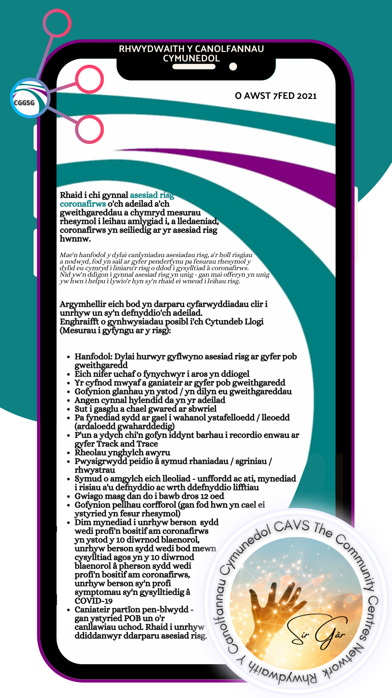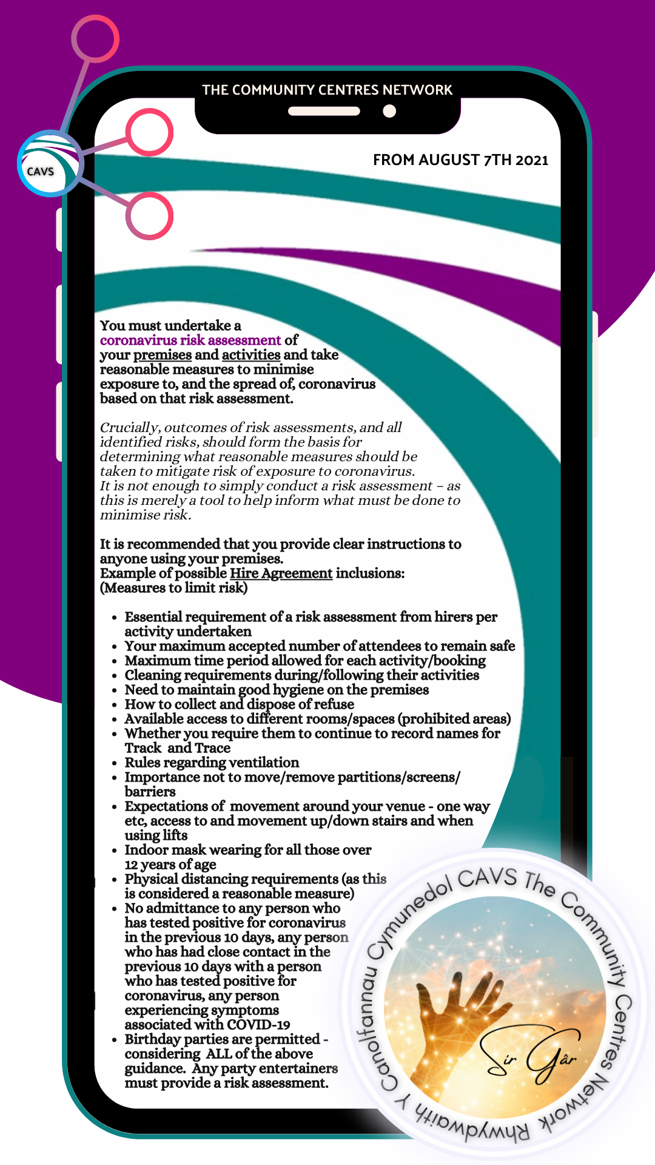
05 | Rhannu gwybodaeth / Diweddariadau  Information share / Updates |  |  | Grŵp / Group
Sian, Caebryn  Sara, Llanelli Mind | Positive meeting with Coop – they are supporting halls/local community groups. Worth contacting your local community pioneer. Support with funding as well as Staff volunteering.  **Partnership with hubbub for community fridges/freezers.  Llanelli mind volunteer befriending - 16-18 year olds. I have posters to share if anyone would like some for their hall.  sarah.risk@llanelli-mind.org.uk
06 | Aelodaeth CAVS / CAVS Membership |  |  | Jamie Horton
CAVS yw’r Cyngor Gwirfoddol Sirol ar gyfer Sir Gâr. Rydyn ni’n darparu gwybodaeth a chefnogaeth arbenigol, rhad ac am ddim i grwpiau gwirfoddol a chymunedol, a’u gwirfoddolwyr.
Rydyn ni’n fudiad sydd ag aelodau.
Mae aelodaeth lawn yn costio £20 y flwyddyn ac mae yna fanteision sylweddol sef :
- Hawliau pleidleisio yng Nghyfarfod Cyffredinol Blynyddol CAVS
- Cyfle i fod yn un o ymddiriedolwyr CAVS
- Gostyngiadau ar hurio ystafelloedd cyfarfod
- Gostyngiadau ar wasanaethau llungopïo
- Gostyngiadau ar gyrsiau hyfforddiant CAVS sydd â ffi
- Gostyngiadau ar system PA sylfaenol
- Gostyngiadau ar hurio teclyn PCC
- Telerau ac amodau yn berthnasol
Ein meysydd gwasanaeth
- Datblygiad a Chyngor ar Nawdd
- Gwybodaeth a Rhwydweithio
- Gwaith Partneriaeth a Chynrychiolaeth
- Hyfforddiant
- Gwirfoddoli
CAVS is the County Voluntary Council for Carmarthenshire. We provide free specialist information and support for voluntary and community groups and their volunteers.
We are a membership organisation.
Full membership costs just £20 per year and brings these benefits :
- Voting rights at CAVS’ Annual General Meeting
- An opportunity to become a CAVS trustee member
- Discounts on meeting room hire
- Discounts on photocopying services
- Discounts on CAVS fee paying training courses
- Discounts on basic PA system
- Discounts on hire of PAT tester
- Terms and conditions apply
Our service areas
- Development & Funding Advice
- Information and Networking
- Partnership Working and Representation
- Training
- Volunteering
07 | Infoengine |  |  | Jamie Horton
This is Wales’ third sector directory and services across the county are using this to refer clients for activities, to book venues etc.
We have added some additional resources to the CAVS website. Click

08 | Gwaith Celf Cymunedol  Community Artwork |  |  | Jamie Horton
 | The Connect the Kindness Carmarthenshire artwork project has produced a beautiful collage which is being shared throughout the county.
Network Action - If you would like a copy to display at your community venue, AM DDIM, please let JH know or contact susansmith@cccpartners.org.uk (Our Carmarthenshire Connector Plus). We have a variety of sizes with all communities represented. Indoors and outdoors.
NOTE – we will be running a competition shortly where people can win some ££ for their community by locating these pieces of artwork. This will also raise your profile.
09 | Unrhyw fater arall  Any other business |  |  | Jackie Dorrian
CAVS are continuing to build their up-to-date information on halls. If you have not done so, please complete the following online form: https://forms.office.com/r/enEwwD4JQ7

10 | Materion ar gyfer y cyfarfod nesaf  Matters for the next meeting
None identified

11 | Dyddiad y cyfarfod nesaf / Date of next meeting | TBC 00/11/2021
12 | Rhwydweithiau / Networks
Children and Young People Network 26/10/2021
Health and Wellbeing Network 28/09/2021
Environment Network – September TBC
Carmarthenshire Food Network 30/11/2021
The Community Centres Network -November TBC
Carmarthenshire Volunteer Organiser’s Meeting (CVON) 05/10/2021
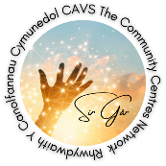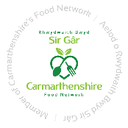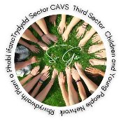

Carmarthenshire Dementia Community Coalition – Email Sue Smith.

NOTE: CAVS and LEADER are interested in your views on the following points – your answers could lead to funding to support an online digital project with Jamie.
- Views of the current Carmarthenshire Halls Website? Good and bad please.
Carmarthenshire Association of Voluntary Services (carmarthenshirehalls.org.uk)
- Do you want an updated and more dynamic version?
  - If yes, do you have any specific requirements? Functionality?
- What equipment would you need to be able to offer online and in-person events at your venue?
- Can you evidence the need of a blended approach to activities from your community.
Please email your responses to Jamie.horton@cavs.org.uk

