Cofnodion / Minutes
Rhwydwaith Network

Tuesday 26/10/2021
10:30 on Zoom

Chris Baker NLCF
Meinir Evans MGSG
Dale James CBSA
Lucy Leach CBSA
Kelly Tomlinson CBSA
Michael & Sheree Jonas Represent Us Rural
Sharan Condon Ty Enfys
Andy Spencer CTCWW
Sally Richards Llanelli Mind
Sarah Llanelli Mind
Belinda Chidemi The Mother & Baby Village
Robert Parker ARA
Vicky Friis CarmDas
Sarah Marslen Undivided
Jackie Dorrian CAVS
Jamie Horton CAVS

Ymddiheuriadau / Apologies:

- Jackie welcomed everyone to the meeting, and a special welcome to Sally Holland for being with us this morning

- Presentation from – Sally Holland - Children’s Commissioner for Wales

Community - Children’s Commissioner for Wales (childcomwales.org.uk)

Coronavirus - Our Work - Children’s Commissioner for Wales (childcomwales.org.uk)
- Information exchange
Represent Us Rural - Working with young people. Doing first podcast this week on Wellbeing and Racism.
Representus.rural | Facebook

CTCWW – getting back to some face to face working lots happening this week as it is half term. Consulting with the young people. Building back more refreshed.

Ty Enfys – Kathryn has now left the organisation, looking for a new youth worker. Managed to build up youth club. Parties happening, 17 year old helping. Family Centre – messy play on a Tuesday. Junior group people on waiting list.
Ty Enfys Family Centre | Facebook

Llanelli Mind – Befriending Sir Gar Youth Project 16 – 24 years supporting about 11 young people, getting out and about in the community. Freshers weeks. Youth presentations in schools. Recruiting for Peer Support befrienders. Getting the message out there.

Mother & Baby – Belinda is a Safeguarding Nurse moved to Wales a few months ago. Charity for Women with children under the age of 4 years, to look at Early Intervention to avoid any mental health psychosis. Only 1 mother and baby unit in Wales. Here to learn and network and see how can help.

ARA – Recovery 4 All – Gambling related support for 16+ and education awareness for school children over 7+. School Beat project linking with Police in schools. Developing relationship with FAW.

MGSG – Blended approach happening currently. Buggy walks restarting. Reflexology started for babies. New activities happening and spreading them across Carmarthenshire. Bilingual Quiz being trialled now. Lots happening. Instagram page please follow. All bookings in advance to be Covid friendly.
- Menter Gorllewin Sir Gar | Facebook

CBSA –

CBSA West Wales | Facebook

CarmDAS - specialist services for those subjected to Domestic Abuse. Work with children and young people and adults. Boundaries Central and towards the west. Calan cover the Ammanford area and Threshold DAS cover Llanelli. Provide fun activities. Support children coming into refuge. Wide ranging service. ACE (Adversary Childhood Experiences) project being delivered based on Rockpool. Welsh Women’s Aid Star programme being run too – face to face sessions. Encourage people with coping strategies. Young people making connections with each other. Adult programmes open for those 15 – 25 too.

Undivided – consultancy just in process of becoming a CIC, training on LGBTQ+. Trans Toolkits. LGBTQ inclusive.
Lots of thanks to the NLCF for all funding coming into Carmarthenshire.

NLCF – Chris is available to contact if you need some information on funding.
(1) The National Lottery Community Fund | Facebook

https://www.dyfedpowys-pcc.org.uk/en/news/press-releases/children-s-rights-charter-ensures-rights-of-children-put-to-the-forefront-in-dyfed-powys/

CAVS update

Welsh Charities Week 15th – 19th November – some incredible work being done. Short stories are welcome please.
Research on our Membership being carried out some organisations being tested in more detail.
Coproducing Mind our Future application with other organisations, we must engage with young people as this is a grass roots application – Mental Health and Resilience – links with LocalMotion potentially.

Two new officers in CAVS – Perminder Dhillon – Capacity Building Officer – Monday - Thursday
Jan Barwell – Development Officer – Wednesday – Friday

CAVS have submitted a proposal to Welsh Government on Loneliness and Social Isolation.

People’s Postcode Lottery have a Welsh funding available.

Funding Drum – happens once a month keep an eye on our website

 | Dyddiad y cyfarfod nesaf  Date of next meeting | 20/01/2022 10.30am https://www.eventbrite.co.uk/e/children-and-young-people-network-rhwydwaith-plant-a-phobl-ifanc-tickets-223289373527
Rhwydweithiau
Networks
- Children and Young People Network - CGGSC~CAVS
- Community Centres Network - CGGSC~CAVS
- Environment Network - CGGSC~CAVS
- Health and Well-being Network - CGGSC~CAVS
- CVON - CGGSC~CAVS
- Food Network - CGGSC~CAVS
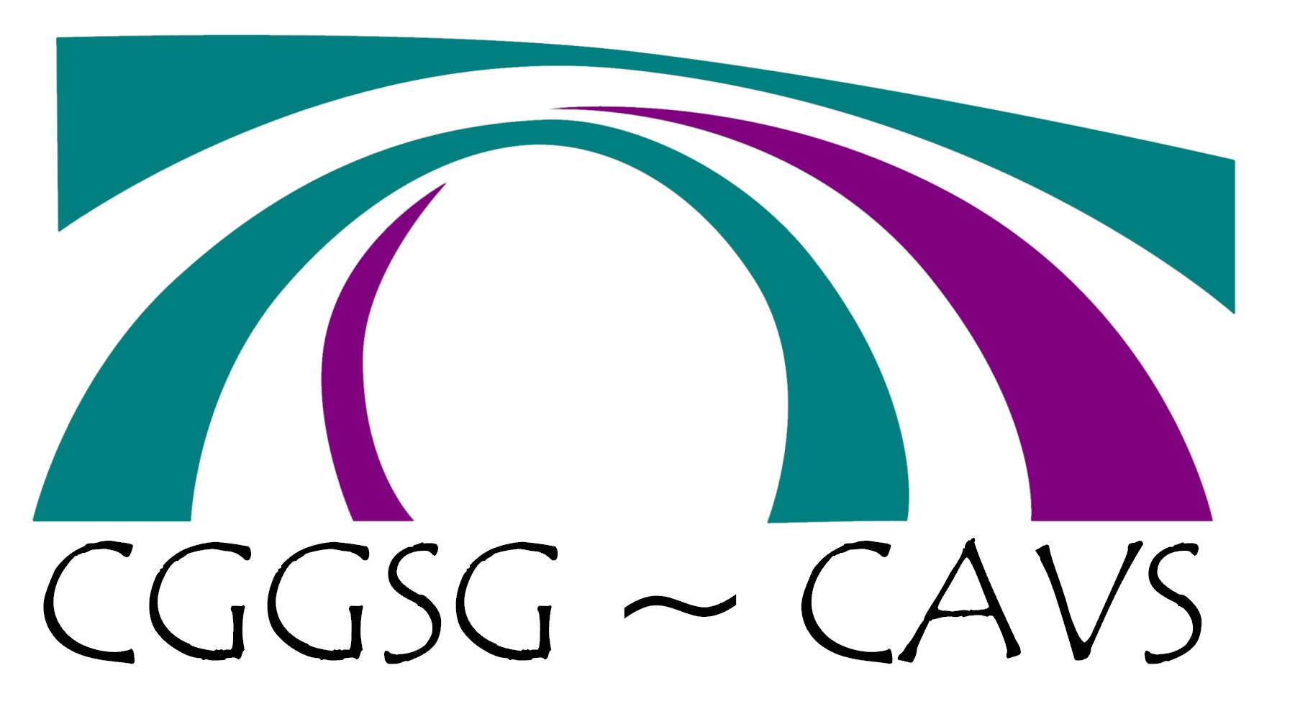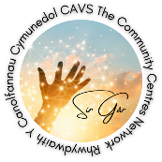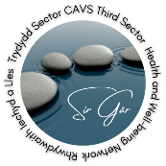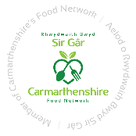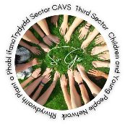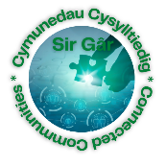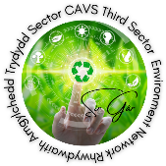
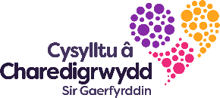

Carmarthenshire Dementia Community Coalition – Email Sue Smith.

Third Sector Support Wales (TSSW) 19 CVCs and WCVA
Portals available to the sector.
- https://thirdsectorsupport.wales/
- https://infoengine.cymru/
- https://carmarthenshire.volunteering-wales.net/vk/volunteers/index.htm
- https://funding.wales/
- CAVS have a new learning portal - have a look at the courses we are offering: https://cavs.org.uk/learning/learning-portal/
- https://www.connecttokindness.wales/
- https://www.facebook.com/groups/1103307530047266
- https://connectcarmarthenshire.org.uk/ (18+)

If you do not have information on Infoengine it is suggested that you sign up and put information on the site. Infoengine is linked to Dewis. We are looking at ways these sites could be linked with ConnectCarmarthenshire.

- Any Other Business

Dates of next meeting: Thursday 20th January 2022
via Zoom for the moment, it could be a blended approach we will see what pans out.

- CAVS website https://cavs.org.uk/events/children-and-young-people-network/

- Eventbrite : https://www.eventbrite.co.uk/e/children-and-young-people-network-rhwydwaith-plant-a-phobl-ifanc-tickets-223289373527

- Everyone thanked for attending the meeting. If anyone has anything to share, then please send to Jackie.
- Presentations by Llanelli Mind and CTCWW

- The Purpose of this group
- Bring likeminded people working with children and young people in the county share expertise, issues i.e. lockdown, doing things correctly.
- Share practice, addressing difficult times, support from each other and share what has worked and what does not work.
- Ways to be innovative with activity packs.
- Home schooling, difficult right now – COVID Fatigue
- Link with other organisations to see how to move forward especially currently
- New legislation updates
- Big get together to celebrate what we do
- Partnership bids
- Include surveys in activity packs
- Training on Excel and other digital products

Next meeting: 20/01/2022
https://www.eventbrite.co.uk/e/children-and-young-people-network-rhwydwaith-plant-a-phobl-ifanc-tickets-223289373527

