The Purpose of this group
- Bring likeminded people working with children and young people in the county share expertise, issues i.e. lockdown, doing things correctly.
- Share practice, addressing difficult times, support from each other and share what has worked and what does not work.
- Ways to be innovative with activity packs.
- Home schooling, difficult right now – COVID Fatigue
- Link with other organisations to see how to move forward especially currently
- New legislation updates
- Big get together to celebrate what we do
- Partnership bids
- Include surveys in activity packs
- Training on Excel and other digital products

Cofnodion / Minutes 4
Rhwydwaith Network 4

Tuesday 20/01/2022: 10:30 on Zoom

Gwawr Williams /MGSG
Kelly Tomlinson /Foothold Cymru (formerly CBSA)
Sharan Condon /Ty Enfys
Rhys Oram /Llanelli Mind
Rob Venus /Cwmaman Community Council
Rob Allen /Aberystwyth Mind
Sarah Powell /Caramrthenshire County Council
Eve Jones /Dr Mz
Gayle Harris /Dr Mz
Jackie Dorrian /CAVS
Jamie Horton /CAVS

Jackie welcomed everyone to the meeting, Happy New Year to all.
Minutes of last meeting – positive as Sally Holland was with us. All minutes of Network meetings are on our website under Engagement –
https://cavs.org.uk/engagement/children-and-young-people-network/

New Children’s Commissioner for Wales in April 2022 Rocio Cifuentes looking forward to seeing what she is going to bring to the role - Community - Children’s Commissioner for Wales (childcomwales.org.uk)

Presentations
- May – CTCWW & MGSG
- September Meeting Dr Mz

Presentations

Llanelli Mind – Rhys Oram – Please note that the Befriending Service covers Carmarthenshire
- Dr Mz offered the youth centre for Befrienders to bring those befriended for a coffee and meet others. Foothold also would offer this.

- Ty Enfys also offered some introductions.

- Out of Hours services are really needed for young people – Twilight Sanctuary available.

Mind Aberystwyth – Rob Allen

https://mindaberystwyth.org/side-by-side-cymru-2/

Registration for next Weds online peer support event at 10am https://www.eventbrite.co.uk/e/side-by-side-cymru-information-event-tickets-228950315557

Assistance with Fuel Poverty - https://gov.wales/discretionary-assistance-fund-daf

ACTION: Who would you like to come and speak to the group, all to think if there is anyone?

Information exchange

Ty Enfys – New Youth Worker Faye worked with Ty Enfys for several years. Email address will be shared with Jackie. New Activity Support worker to be recruited to.
Planning is being looked at currently, opening more services back up. Family Support worker is isolating currently.
Funding still in place. Received Carmarthenshire Connected Communities Fund Grow Space – volunteers starting soon on this. Group to look at how to work with residents to look at how to grow in their own garden. Working with Men’s Sheds on making raised beds.
Jubilee coming this year hoping to do something to celebrate.
Ty Enfys Family Centre | Facebook

MGSG – January feels like a long month, celebrated Christmas with shows in 3 areas. Some people still feel uncomfortable so face to face in some areas as well as virtual. Story sessions and baby reflex sessions. Quiz running. Week of activities to promote wellbeing and being outdoors at half term. Profi busy presenting with other Menter’s in the county in the Colleges via Goggle meet. Digital resource podcasts being developed. Website being developed and Meinir will present at the next meeting if it is up and running.
- Menter Gorllewin Sir Gar | Facebook

Youth Service CCC – Lots going on. Period Poverty – supply eco-friendly sanitary products for anyone in the community. WG have funded again. Sarah can deliver or you can collect get in touch with Sarah. Links with the Food Network as well. Food Poverty Fuel Poverty Period Poverty links.
PERIOD POVERTY SIR GAR Gwybodaeth am y prosiect - https://youthsirgar.org.uk/periodpoverty/?lang=cyInformation

https://youthsirgar.org.uk/period-poverty/Sefydliadau/Lleoliadau i gael cynhyrchion am ddim - https://youthsirgar.org.uk/list/?lang=cyOrganisations/Locations
to access free products –
https://youthsirgar.org.uk/list/
Ymunwch yn y sgwrs ar y cyfryngau cymdeithasol drwy ddefnyddio #PeriodPovertySirGâr
Join in the conversation on social media by using #PeriodPovertySirGâr

Carmarthenshire Youth Council – group of young people 11 – 21 years, represent the young people of Carmarthenshire. Raise Young people’s issues, protecting the environment domestic abuse and violence. Spaces available please contact Sarah or Iwona - Iwona Mainwaring 07769305470 IMainwaring@carmarthenshire.gov.uk

Face to face meetings taking place small groups.
Carmarthenshire youth council www.youthsirgar.org.uk

Dr Mz – Vacancies at Dr Mz
https://findajob.dwp.gov.uk/details/7830958https://findajob.dwp.gov.uk/details/7830969https://findajob.dwp.gov.uk/details/7830966
Been busy through lockdown, open since August 2021. Funding success but lost 3 staff and another going on Maternity leave. It is a great place to work flexible. Growing, cooking transforming projects happening. Financial Literacy project started.
Umbrella project teaching young people new skills. Residential in Bristol in February 2022. All looking forward to going. Doing activities may not have done before. Skills with young people around jobs. Plumber, Carpentry, Sound sessions.
Giving young people more opportunities.

Cwmaman Community Council – NSPCC has just published data for last year. One of the harmful things coming out is the safety of children using social media. Note of caution using certain platforms Tik Tok and Instagram be careful when using these due to not being able to put safety measures in place.
Green Infrastructure – consultation on Carmarthenshire Play Strategy currently, CCC. Looking to develop an outdoor classroom, working with Coed Lleol – Small Woods. Woodland wellbeing.
Maker Space – available to young people. Arts, design type of work. 3D printers are available contact Rob.
Wellbeing and Future Generations – councils working together on this.
Safeguarding Training and Updating is important for staff and Board members.

Lots of thanks to the NLCF for all funding coming into Carmarthenshire.

NLCF – Chris is available to contact if you need some information on funding.
(1) The National Lottery Community Fund | Facebook

CAVS update
Carmarthenshire Food network – 9th February open to anyone including growing projects.
Webruary – colleagues across the region working together around Digital work, supporting community halls and venues to be able to offer a blended approach. Dedicated the whole of February to support the work. Please contact Jamie if you want to link in and do something during the month. Anything that is being delivered online.

Research on CAVS Membership being carried out some organisations being tested in more detail, work still ongoing.

New member of staff in CAVS – Michael Jonas – Funding Assistant
New Network – Befriending Network all welcome if you offer a Befriending Service 22nd February 10.30 – 12.30 an introductory network.

Networks – issues arising:
Safeguarding Training and Updating is important for staff and Board members.
- Knowledge Hub has training courses - https://thirdsectorsupport.wales/

New campaign aims to stop more encrypted apps
Social media and online safety | NSPCC Learning

Staffing is a big issue – organisations are advertising several times
Mind our Future Programme bid is going to Assessment in February 2022 looking at possibility in young people assisting to write the Job Descriptions for the 6 posts that will be available

Carmarthenshire Connected Communities Fund – working out what funding is still available.
In April there will be a new round for grass roots organisations.

CAVS developing Training Programme.
Date for AGM coming soon.

Third Sector Support Wales (TSSW) 19 CVCs and WCVA
Portals available to the sector.
- https://thirdsectorsupport.wales/
- https://infoengine.cymru/
- https://carmarthenshire.volunteering-wales.net/vk/volunteers/index.htm
- https://funding.wales/
CAVS have a new learning portal - have a look at the courses we are offering: https://cavs.org.uk/learning/learning-portal/

- https://www.connecttokindness.wales/
- https://www.facebook.com/groups/1103307530047266
- https://connectcarmarthenshire.org.uk/ (18+)

If you do not have information on Infoengine it is suggested that you sign up and put information on the site. Infoengine is linked to Dewis. We are looking at ways these sites could be linked with ConenctCarmarthenshire.

Any Other Business

Dates of next meeting:
via Zoom for the moment, it could be a blended approach we will see what pans out.

CAVS website https://cavs.org.uk/events/children-and-young-people-network/

Eventbrite : https://www.eventbrite.co.uk/e/253210568627 May 10th.

Everyone thanked for attending the meeting. If anyone has anything to share, then please send to Jackie.

Dates for future meetings:
Tuesday 10th May 10.30 – 12.30
Tuesday 13th September 10.30 – 12.30
Tuesday 17th January 2023 10.30 – 12.30

CAVS Networks
- Children and Young People Network - CGGSC~CAVS
- Community Centres Network - CGGSC~CAVS
- Environment Network - CGGSC~CAVS
- Health and Well-being Network - CGGSC~CAVS
- CVON - CGGSC~CAVS
- Food Network - CGGSC~CAVS
- Befriending Network - CGGSC~CAVS

https://cavs.org.uk/engagement/

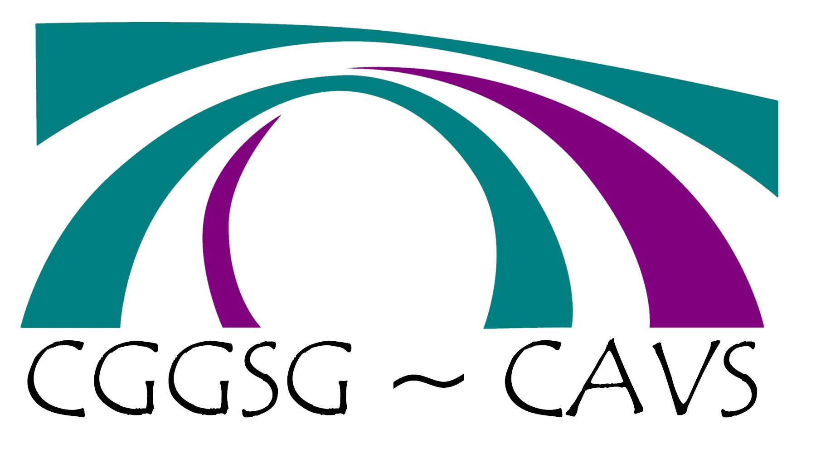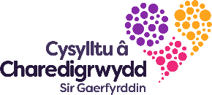
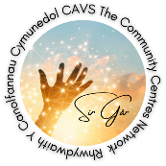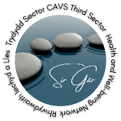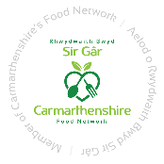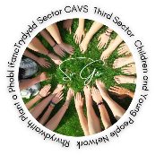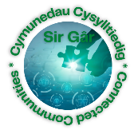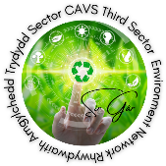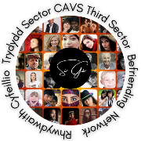

Carmarthenshire Dementia Community Coalition – Email Sue Smith.

