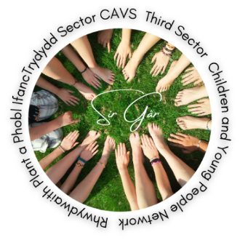

Agenda

Dyddiad/ Date | Amser / Time | Lleoliad / Venue | #
10/05/2022 | 10.30 | Online  https://www.eventbrite.co.uk/e/children-and-young-people-network-rhwydwaith-plant-a-phobl-ifanc-tickets-337147586507 | 005

Bydd cyfarfodydd drwy Zoom yn cael eu recordio i gefnogi gydag adroddion a chofnodion ac er mwyn rhannu cyflwyniadau y cytunwyd arnynt YN UNIG (Oni chytunir fel arall).
Meetings via Zoom will be recorded to support with minute reporting and sharing of agreed presentations ONLY (Unless agreed otherwise).
# |  | Dan arweiniad / Led by
01 | Croeso ac Ymddiheuriadau  Welcome and Apologies | Jackie Dorrian
02 | Rhagarweiniad gan y mynychwyr  Introduction from those in attendance | Grŵp / Group
03 | Slot cyflwyno  Presentation slot | Carers Trust Crossroads West Wales (CTCWW) – Cat Hooton – Young Carers in Carmarthenshire
04 | Slot cyflwyno  Presentation slot | Menter Gorllewin Sir Gar – Meinir Evans
05 | Rhannu gwybodaeth / Diweddariadau  Information share / Updates | Grŵp / Group
06 | Unrhyw fater arall / Any other business | Jackie Dorrian
07 | Materion ar gyfer y cyfarfod nesaf  Matters for the next meeting | Jackie Dorrian
08 | Dyddiad y cyfarfod nesaf / Date of next meeting | 13/09/2022 10:30
Rhwydweithiau CAVS
CAVS Networks

Carmarthenshire Association of Voluntary Services
Cymdeithas Gwasanaethau Gwirfoddol
Sir Gâr
Y Mwnt, 18 Heol y Frenhines
CAERFYRDDIN SA31 1JT
Ffôn 01267 24 55 55
E-bost admin@cavs.org.uk
The Mount, 18 Queen Street
CARMARTHEN SA31 1JT
Tel 01267 24 55 55
E-mail admin@cavs.org.uk

The Purpose of this group
- Bring likeminded people working with children and young people in the county share expertise, issues i.e. lockdown, doing things correctly.
- Share practice, addressing difficult times, support from each other and share what has worked and what does not work.
- Ways to be innovative with activity packs.
- Home schooling, difficult right now – COVID Fatigue
- Link with other organisations to see how to move forward especially currently
- New legislation updates
- Big get together to celebrate what we do
- Partnership bids
- Include surveys in activity packs
- Training on Excel and other digital products

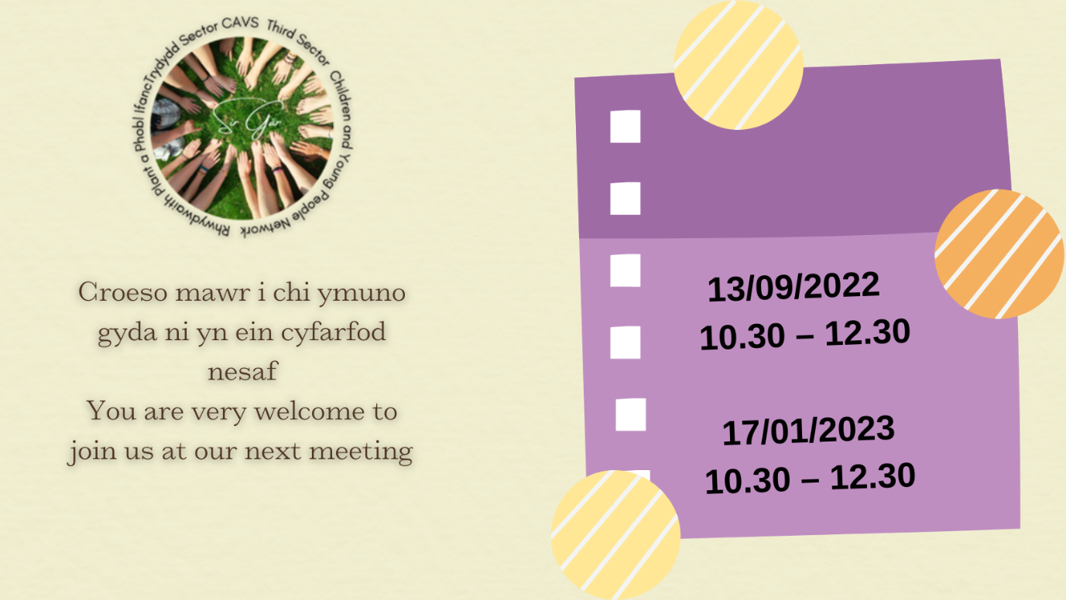

Carmarthenshire Association of Voluntary Services
Cymdeithas Gwasanaethau Gwirfoddol
Sir Gâr
Y Mwnt, 18 Heol y Frenhines
CAERFYRDDIN SA31 1JT
Ffôn 01267 24 55 55
E-bost admin@cavs.org.uk
The Mount, 18 Queen Street
CARMARTHEN SA31 1JT
Tel 01267 24 55 55
E-mail admin@cavs.org.uk

Cofnodion / Minutes
Rhwydwaith Network
Dyddiad/ Date | Amser / Time | Lleoliad / Venue | #
10/05/22 | 10.30 | Online | 005

Presenoldeb yn y cyfarfod / Meeting attendance
Mynychwyr  Attendee | Rôl  Role | Yn bressenol Attendance | e-bost neu gyfryngau cymdeithasol  email or social media
Sally Richards |  | Llanelli Mind | - Website
Sarah Risk |  | Llanelli Mind | - Facebook
Ryan Stephens |  | Llanelli Mind
Cat Hooton |  | CTCWW | - Facebook
Christina Jenkins |  | Plant Dewi | - Facebook
Sarah Powell |  | Carmarthenshire County Council
Georgie Bailey |  | Forest School
Meinir Evans | Profi | MGSG | - Facebook
Jackie Dorrian | Senior | CAVS | Jackie.dorrian@cavs.org.uk
Jamie Horton | CVDO | CAVS | Jamie.horton@cavs.org.uk

Bydd cyfarfodydd drwy Zoom yn cael eu recordio i gefnogi gydag adroddion a chofnodion ac er mwyn rhannu cyflwyniadau y cytunwyd arnynt YN UNIG (Oni chytunir fel arall).
Meetings via Zoom will be recorded to support with minute reporting and sharing of agreed presentations ONLY (Unless agreed otherwise).

# |  |  |  |  | Dan arweiniad / Led by
01 | Croeso ac Ymddiheuriadau  Welcome and Apologies |  |  |  | Jackie Dorrian
Jackie welcomed everyone to the meeting, Happy New Year to all.
Minutes of last meeting –All minutes of Network meetings are on our website under Engagement

New Children’s Commissioner for Wales in April 2022 Rocio Cifuentes looking forward to seeing what she is going to bring to the role - Community - Children’s Commissioner for Wales (childcomwales.org.uk)

02 | Rhagarweiniad gan y mynychwyr  Introduction from those in attendance |  |  |  | Grŵp / Group
03 | Slot cyflwyno / Presentation slot: Carers Trust Crossroads West Wales (CTCWW) – Cat Hooton – Young Carers in Carmarthenshire
Congratulations to Andy who is on Paternity leave.

Every LA has a duty to ensure young carers have what they need. LA works with most high-level cases, i.e., single parent families or situation high end.
All other carers come to the Young Carers project. Work with young adults 5 – 25-year-olds. What we do depends on their needs.
One to one work, visits in school, college, take them out. In the meetings do you have the right benefits, do you need carers to come in and CTCWW help to sort out. Look at child’s own needs i.e., are they getting to go out and do what they want i.e., football or meet friends at Starbucks.
Peer Support groups, fun activities, workshops, confidence building.
Key Project 5 – 18-year-olds
Mainstream section of the project, can talk to others and build a network
Specific stream for a sibling who has autism. Little or no resources around a child with autism. Created a group invited 45 children to last session.

YAC Project Young Adults Carers 16 – 25-year-olds
Employability
Grant for driving lessons
Link with Youth Service
I.D. Card launched recently- young person can show to a pharmacist or at the doctors
Key Project 120 children only 1 full time worker and 1 part time member of staff
YAC 50 - 60
In Secondary School 3 young carers in each class. It can go up to 1:5
Highest proportion of young carers in Carmarthenshire
Groups meet (just started to meet again) fear around coming to groups Carmarthen and Llanelli are running
YAC have more informal meetings
It is what suits, and we offer transport
There are many that are not captured as young carers across Carmarthenshire
Feedback from Sarah – praising the work that is done on these projects
https://ctcww.org.uk/young-carers/
04 |  | Slot cyflwyno / Presentation slot: Menter Gorllewin Sir Gar – Meinir Evans
Support local community with lots of activities. 3 Menter Ilaiths in Carmarthenshire.
Support families, drama clubs, walks for families in the parks. Forum for young people to develop projects in the community. Gig in June.

Profi Project – supports young people with skills from the journey from school to the next stage. A website is going to be in place very soon, it has been tested but there is some work to do. Suitable for those year 10 onwards. Young people wanted videos to help support them to gain skills.
Short video clips with lots of information for the young people.
300 young people have tested it, good feedback so able to move on with the Website.
Meinir will come and give a guide on the website at the next meeting, she is willing to talk to organisations to look at the website and talk through it.
Templates are on Instagram on a Linktree
- https://www.mentergorllewinsirgar.cymru/prosiectau?lang=en&msclkid=a24e60b3d04711ecaec61a2666c65580
- https://www.youtube.com/playlist?list=PLct2_PIFAwjkT2Bn4FRV3_wdTYffYV6Bk
- https://www.instagram.com/mentergsg/
- http://www.instagram.com/cynllunprofi/

05 | Rhannu gwybodaeth / Diweddariadau  Information share / Updates |  |  |  | Grŵp / Group
Jackie CAVS
- Funders are looking for partnership applications. Start to think about who you may want to partner with. If organisations want to look at working together then please email Jackie with some information.
- Mind Our Future bid was not successful unfortunately. We will be looking at partnership bid for People & Places as a partnership.
- Young People asked for more “Out of Hours” Services.
- Voices of young people need to be heard.
- Youth Manifesto CCC developing, more capable young people developing.
- Julian Decent is developing the Pupil Voice as part of the new curriculum.
- MGSG holds a Young People’s Forum.
- Between us all there is a lot of information about young people.
- CAVS Membership being changed more information to come soon. Our Membership is now Free.
Everything is going Digital, we will support groups that have difficulty in connecting.
- Look at the funding that is currently available from CAVS website
- Regional Governance Conference – Trustees of all organisations should be made aware of the sessions on our website
- DBS training coming soon
- Charity Commission video on Safeguarding
Plant Dewi
Under Families First project a drive again participation standards again, young people coming out to look at services on the ground. Young Parents looking at how to get their voice heard.
Celebrating 20th anniversary, there was a celebration yesterday with the bishop lit and blessed a candle and the original Manager the candle will travel around the three counties. Events will be happening so all are welcome.

Woodland/Forest School
Woodland, meadows. Forest school business in development stage. Want to find out if there is a need. Georgie has over 10 years of experience. Provide a space for people to openly talk about their experiences. Developing some Market Research and developing a Business Plan currently. Is there a need for this type of service?
Lots of Woodland projects and Forest Schools – where are the connections. Families, Intergenerational working young carers, Family Centres to tap into this work.
Tir Coed, Coed Lleol/Small Woods
Summer holidays what is happening in the community?
Family Centres, all of them have just trained to deliver Forest schools with Tir Coed. Delivery outdoors. Always looking for new opportunities.
Winter Wellbeing and Summer of Fun funding was used.
Youth Service CCC
So much happening. Period Poverty project £157k per year all allocation been spent on products. Needs to be more strategically led now, and things to be distributed. Sarah can drop things off if people need anything.
Youth Council – if you know of any young people who would like to join 11 – 21-year-olds, then please contact Sarah or Iwona. Young people voted for make your mark consultation is Mental Health & Wellbeing.
imainwarign@carmarthenshire.gov.uk or visit www.youthsirgar.org.uk

Working with orgs around Domestic Violence, consultation being sent out. Journey of the young person if disclosed what would the journey look like and what professionals would be involved.
Young Person Elected for UK Youth Parliament. Channels to be set up. Working with Children in Wales.
Young people sit on Children in Wales panels.
Michael Langford Hywel Dda Sarah met with him– School in Reach project how teachers in schools can get supported in Mental Health. How whole school support young people. Train staff and school staff on how to support. Pilot done in Ceredigion.
Michael is offering Children, Young People and Families in Carmarthenshire the opportunity to share their opinions and suggestions on the design of a new mental health and emotional wellbeing service - School In-Reach. He would be interested in coming along to groups to hold a focus group session to seek the views and opinions of the children, young people and families, members of the network work with to find out what they think is important when considering any mental health and emotional wellbeing provision within school.
Focus Group information in brief:
PROJECT: School In-Reach
THEME: Mental health and emotional wellbeing service
AGE: School age children, young people and their families
TIME: to be complete mid-June (this is flexible)
CONTACT DETAILS: Michael Langford, Michael.E.Langford@wales.nhs.uk
Food Poverty Fuel Poverty Period Poverty
- https://youthsirgar.org.uk/periodpoverty/?language=cyInformation
- https://youthsirgar.org.uk/list/?lang=cyOrgansiations/Locations
- To access free products:
- https://youthsirgar.org.uk/list/
Ymunwch yn y sgwrs ar y cyfryngau cymdeithasol drwy ddefnyddio #PeriodPovertySirGâr
Join in the conversation on social media by using #PeriodPovertySirGâr
Face to face meetings of small groups now taking place.
Whole School Approach also working on.
Estyn Report “We don’t tell our teachers”. Peer on peer harassment is happening in our schools. CCC have written a plan around the Estyn report.
Transition from CAHMS to Adult services – work being done around this; Pembrokeshire is looking at this first.
Young people do not want things done to them they want to lead on things.
Not enough Counselling services available for young people. Some issues around CAHMS as well. Although CAHMS do great work. Waiting times were a concern. Impact of working at home and being isolated.
The importance of Early intervention and development of Peer Support but needs a lot of support.
Llanelli Mind
Befriending Service – Carmarthenshire Service only – People aged 16 – 94 years
16 -24 Youth Befriending
Youth befriending referrals not been high. Colleges have put in Welfare Officers. Been so successful and some amazing quotes from young people who have used the service. Peer Mentors are in place.
Wrap around service. Work with other organisations to provide out of hours services, weekends, and evenings. Lots of joint working.
Befriending goes on for 6 – 9 months and refer/signpost to other services when required.
Regular contact is the key to build up trust. Get some nice matches and watch the development of those requiring the service.
Low to moderate Mental Health needs you can refer using the form on the website - https://www.llanelli-mind.org.uk/
Simple form and Llanelli Mind will do an assessment within 10 days maximum.
Mobile Befriending hope to start soon, so be able to be in local communities which are isolated and social deprivation.
Meinir to contact school that is offering services and pass to Sally.
CYP has finally started, 11 – 24 years, new project inclusive environment, staff project workers delivery with a group. New base, for Llanelli Mind. Utilise other things that are currently out there, such as People SpeakUp and the Woodland project.
Enhancing Wellbeing – young people don’t often understand the terminology. Getting active, engaging the community, get creative, arts, crafts, embrace our space. Parks, beach etc
Drop-in Centre available for 2 hours once per week. Young people having a voice and for them for them to do what they want.
Tuesday day ad evening and Friday evening – for those NEET.
Saturday and Sunday daytime.
cyp@llanelli-mind.org.uk
Just in Llanelli now. Link with other projects across the county.
75% of young people who need support don’t get it, as some feel they don’t need it.
https://www.nhs.uk/mental-health/self-help/guides-tools-and-activities/five-steps-to-mental-wellbeing/

Jamie CAVS
- Kindness projects – linked with Men’s Sheds 3 of them to create some Kindness Benches. Emails going to community members to encourage involvement. Long term sustainability of the benches, looking for Kindness Champions. (Ferryside, Pembrey and Burryport, Llandeilo/Llandovery/Llangadog)
- Kindness Murals – working with schools, commissioned to look at kindness messages, co-produced with the community. Potential for an artist to be commissioned. (Penboyr, Kidwelly, Crosshands).
- Volunteers Week 1 – 7th June 2nd and 3rd Jubilee Celebration. Stories are welcome from all that are Volunteering. Asking if any communities are having a part for Jubilee, then would like to have stories from communities.
- CAVS in conversation – we are offering all organisations time to come and have a 5-minute conversation with us to tell us about your organisation and what you are looking for with respect to volunteering. Looking at formal and informal volunteering.
CAVS can promote any events that are coming up if you have anything that you need assistance with. Provide us with bilingual information and we can promote as well as see if anyone comes forward to volunteer. (Partnership of volunteering wales / connect Carmarthenshire / cavs website and social media: FB, Twitter).
Guide Digital
Tempo Time Credits
1. Dr Mz / 2. Xcel Community Furniture Shop / 3. All About Us! / 4. Shadows Depression Group / 5. Burry Port Town Council / 6. Burry Port Grab & Bag / 7. CBSA / 8. Betws Family Centre / 9. Incredible Edible / 10. LINKS Llanelli
11. West Wales Walking for Wellbeing / 12. Carmarthenshire Libraries / 13. Carms 50+ Forum / 14. Bynea District Forum / 15. Menter Cwm Gwendraeth Elli / 16. Llanelli LGBTQ+ Support Group / 17. CASM / 18. Llanelli MIND befriending project / 19. Arts Care Gofal Celf / 20. Carmarthen Community Money Advice Centre /
21. Carmarthen Foodbank / 22. CETMA Ltd / 23. Cwmaman Town Council / 24. Links - Combined Forces Project / 25. Pwll Residents Association / 26. ReConnecting / 27. Stordy Creadigol / 28. The HangOut / 29. West Wales Action for Mental Health / 30. Fusion Carmarthenshire / 31. South Cefncaeau (TY ENFYS) Family Centre / 32. Repair cafe Llanelli /33. Radio BGM / 34. NDCW Carmarthenshire Theatres / 35. Tir Coed Carmarthenshire / 36. TACLO / 37. Llandeilo Lit Festival /38. LTC Mowing /39. Dyfed Powys Police&Crime Comm / 40. Walking Well Carms / 41. Theatrau Sir Gâr /42. Ski4All Wales / 43. Field Bay Homes - Ty Cwm Gwendraeth / 44. Field Bay Homes -Cwm Gwendraeth /45. Menter GSG-Profi /46. Menter Dinefwr /47. Llanelli Ramblers Volunteers / 48. People Speak Up / 49. Threshold DAS / 50. The Family Foundation / 51. Menter Gorllewin Sir Gar / 52. Ysgol Pen Rhos / 53. Dogs4Wildlife / 54. Llanelli Railway Goods Shed / 55. CYCA / 56. Yo Yo's Kidz Club / 57. Trallwm Area Community Hall

- ConnectCaramerthenshire
- Connected Communities Sir Gar
- Digital – community halls that have equipment for Hybrid sessions. Tallog, Llandeilo Hengwrt, Laugharne Memorial. (Groups may be interested in an Owl 360 degree camera/speaker/microphone for meetings-expensive but inclusive).
- Participatory Budgeting – worked with Llandeilo community to support local decision making.
- Food Network – any group supporting food related activities / working with food poverty get in touch. Facebook group
06 | Unrhyw fater arall / Any other business
Cwblhewch ein harolwg anghenion hyfforddi erbyn 30 Mehefin 2022 a byddwch yn cael eich cynnwys mewn raffl i ennill talebau gwerth £100.00.
Complete our training needs survey by 30th June 2022 and you will be included in a raffle to win vouchers worth £100.00.

Cymraeg: https://www.surveymonkey.co.uk/r/SGZJMNV
English: https://www.surveymonkey.co.uk/r/GYKCK5S

Third Sector Support Wales (TSSW) 19 CVCs and WCVA
Portals available to the sector.
- https://thirdsectorsupport.wales/ (Please sign up to TSSW Knowledge Hub there is a huge amount of great information on there).
- https://infoengine.cymru/ (If you do not have information on Infoengine it is suggested that you sign up and put information on the site. Infoengine is linked to Dewis. We are looking at ways these sites could be linked with ConnectCarmarthenshire).
- https://carmarthenshire.volunteering-wales.net/vk/volunteers/index.htm (Contact Alud.jones@cavs.org.uk for support with this platform)
- https://funding.wales/

CAVS have a new learning portal - have a look at the courses we are offering: https://cavs.org.uk/learning/learning-portal/
- https://www.facebook.com/groups/1103307530047266
- https://connectcarmarthenshire.org.uk/ (18+ for Timebanking)
07 |  |  | Materion ar gyfer y cyfarfod nesaf  Matters for the next meeting
- September Meeting Presentation Dr Mz
- September Meeting Presentation Llanelli Mind CYP project
08 |  |  | Dyddiad y cyfarfod nesaf / Date of next meeting | 13/09/2022 10:30 https://www.eventbrite.co.uk/e/children-and-young-people-network-rhwydwaith-plant-a-phobl-ifanc-tickets-337147586507

https://cavs.org.uk/engagement/

- Children and Young People Network - CGGSC~CAVS
- Community Centres Network - CGGSC~CAVS
- Environment Network - CGGSC~CAVS
- Health and Well-being Network - CGGSC~CAVS
- CVON - CGGSC~CAVS
- Food Network - CGGSC~CAVS
- Befriending Network - CGGSC~CAVS

- Connected Communities Sir Gâr Facebook Page
- Connect Carmarthenshire

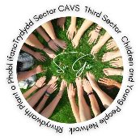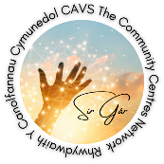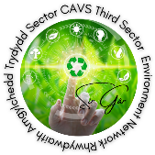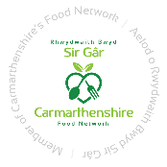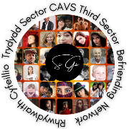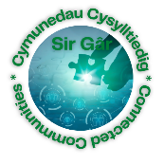
Carmarthenshire Dementia Community Coalition – Email Sue Smith.

