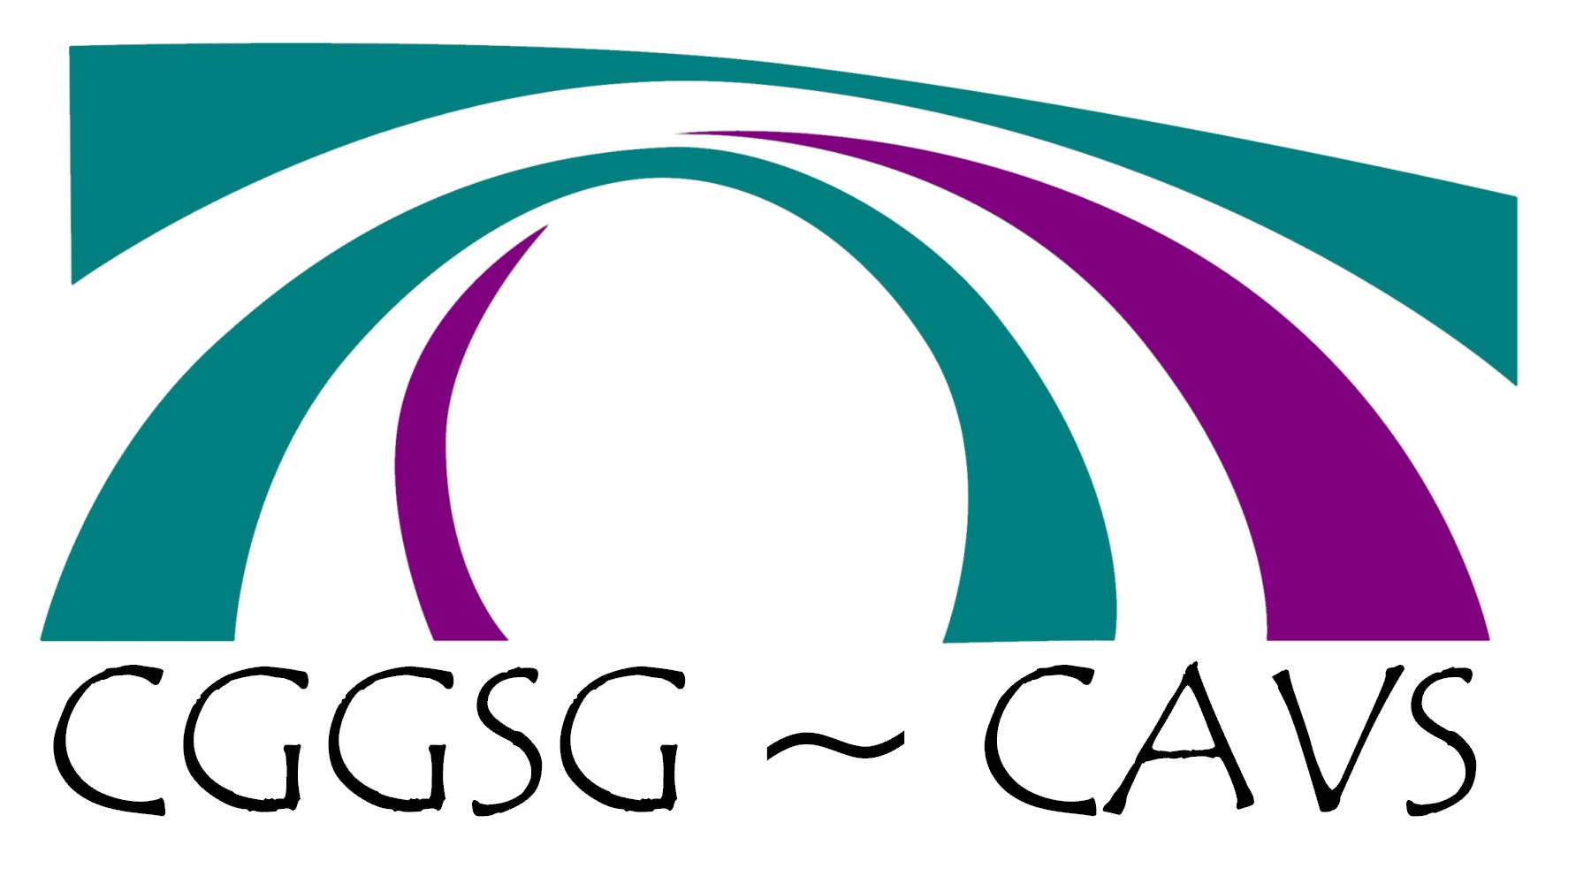
Carmarthenshire
Health & Wellbeing News

Briefing: Pension Credit - Action needed so older people don’t miss out.
Please find attached a briefing from the Older People’s Commissioner for Wales, which highlights why it’s crucial to increase Pension Credit uptake in Wales
https://olderpeople.wales/resource/pension-credit-action-needed-so-older-people-dont-miss-out/
Planning for a Healthy Future.
Working together to create healthier communities.
https://publichealthnetwork.cymru/event/planning-for-a-healthy-future-working-together-to-create-healthier-communities/

Fully funded places available for Innovation Intensive Learning Week 5 – 9 December 2022
https://www.bevancommission.org/programmes/intensive-learning-week/

24/7 well-being line, (the Single Point of Contact for Mental Health line), it is now available 24 hours a day, 7 days a week.
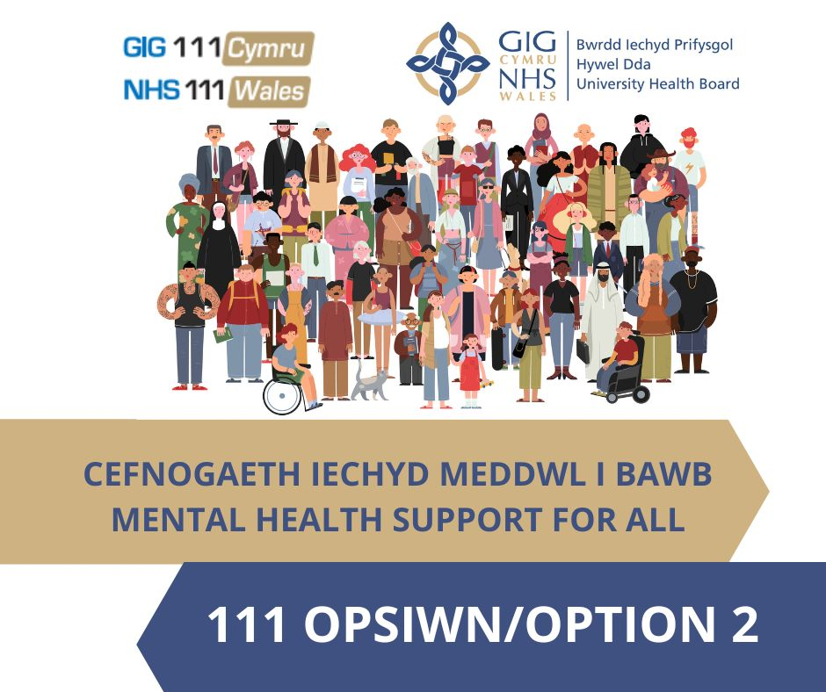

Community Health Council
A yw’r GIG yn gwella wrth fyw gyda COVID? / Is the NHS getting better living with COVID?
A yw’r GIG yn gwella wrth fyw gyda COVID?Yr hyn a glywsom gan bobl rhwng Ebrill a Mehefin 2022
Is the NHS getting better living with COVID?What we heard from people between April and June 2022
I ddarganfod mwy am y gwaith rydyn ni'n ei wneud a sut rydyn ni'n gweithio ar eich rhan, beth am ddilyn ni ar Twitter, Facebook a'n gwefan i gael copïau o'n hadroddiadau ymweld, arolygon, cofnodion cyfarfodydd pwyllgor a mwy!
dolen i'r cylchlythyr:
Briffiau/Cylchlythyron - Cyngor Iechyd Cymuned Hywel Dda (gig.cymru)
dolen i'r arolygon cyfredol: https://hywelddacic.gig.cymru/cymryd-rhan/arolygon-byw/

To find out more about the work we do and how we work on your behalf, why not follow us on Twitter, Facebook and our website for copies of our visiting reports, surveys, committee meeting minutes and more!
Link to newsletter : Briefings/Newsletters - Hywel Dda Community Health Council (nhs.wales)
Link to current surveys : https://hywelddachc.nhs.wales/get-involved/live-surveys/

